**GAS-Global Aid Match System**

1. ***Background***

When disaster occurs, it is difficult for the civil rescue team and the affected party to establish a disaster relief supply chain quickly, often caused by poor information communication and resource allocation. In the 2013 LuShan earthquake, lots of civil rescue cars blindly went to SiChuan province and blocked the rescue route. Consequently, China Central State Council issued an order prohibiting civilian rescue forces from going to the disaster area during disaster.

1. ***Pain Point***   
   1. The lack of system-level rescue solutions

2. The lack of global vision forms an information island

3. The lack of mutual trust mechanism makes it difficult to make an agreement

4. The lack of schemes results in uneven resources allocation

5. The lack of measurement and feedback in the rescue process

6. The lack of information traceability breeds corruption

1. ***Proposal Introduction***

A GAS user is formed and joined in the block-chain through free registration and verification. After a user is formed, he can publish relevant available material information which is visible to all the users on the chain.

When disaster occurs, the user can post rescue request, the chain will broadcast it globally and the GAS node will receive the information. then GAS system will match the demand with the reserved material information according to the resource matching algorithm.

Finally, a working contract is formed and the rescue work is implemented offline.

Users can use the online GAS working group for progress tracking and complete the mutual evaluations after the contract is completed.

1. ***Proposal Process***

Please refer to Our PPT

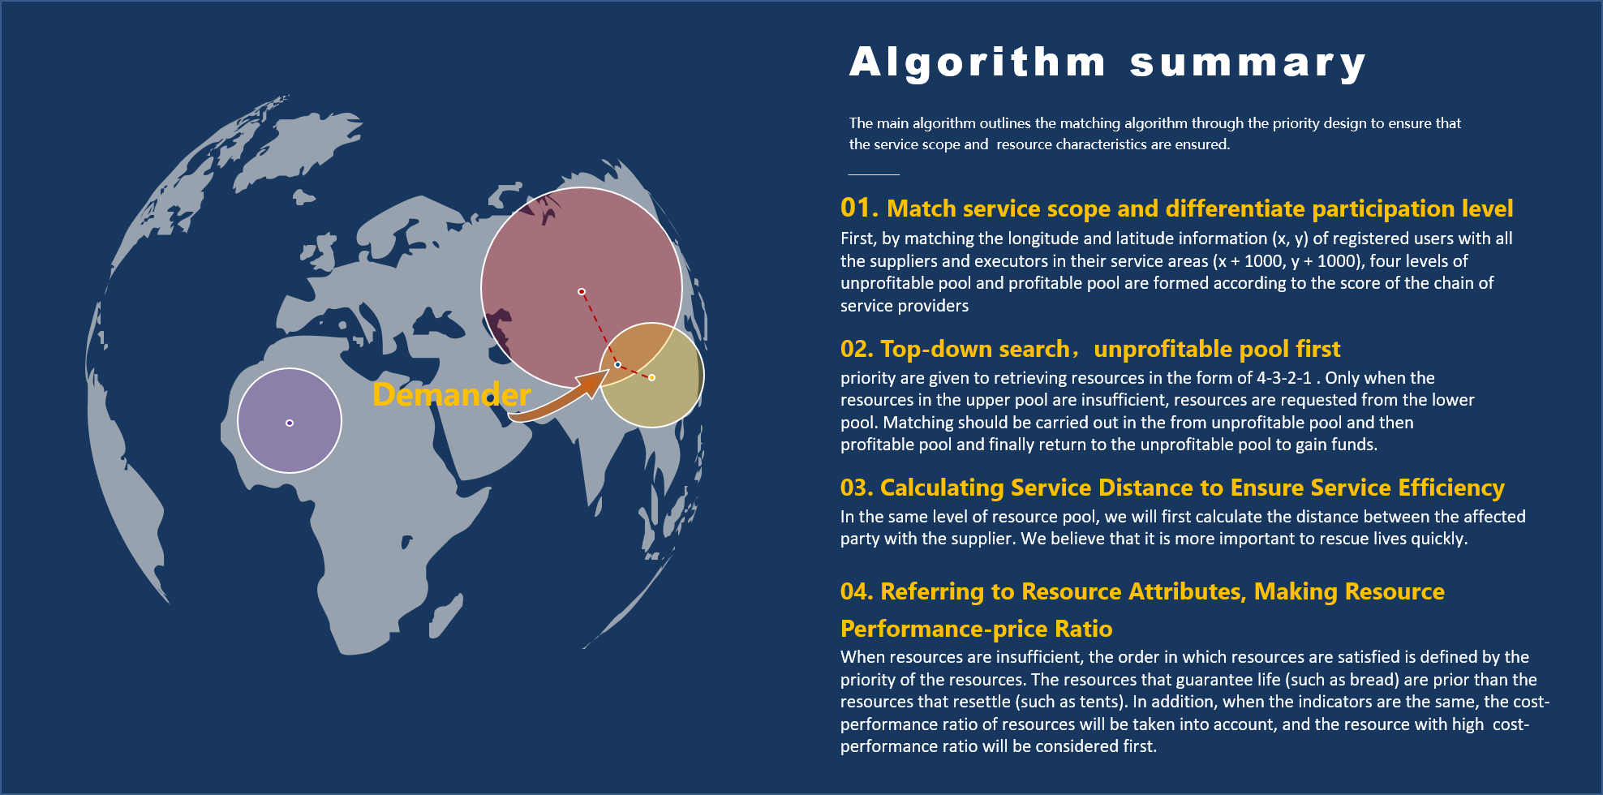

1. ***Proposal Scheme***

Please refer to Our PPT

1. ***Idea Merit***

The value of this idea is mainly that the block-chain technology guarantees the transparency of information and enables all participants to enjoy the GAS system's efficient, trustworthy, and information-traceable features. At the same time, the block-chain technology breaks the information island, establishes a global view assisting system and allocates resources through algorithm to ensure the rationality of resource allocation.

The GAS node acts as a link to closely connect providers, users and beneficiaries to achieve rapid rescue during emergencies.

1. ***Roadmap***

This creation utilizes lots of mature IBM services such as IBM block-chain platform. It is based on the software system and can be easily deployed. In the future, when it is deployed on a large scale, it can be jointly developed with the United Nations, the Red Cross Foundation and other world organizations for its public welfare, and it can be put into operation in a short period of time.

At the same time, this creation is compatible with for-profit organizations and has the ability to operate commercially. After it is put into operation, it can form self-nurturing products through commercial means, such as collecting membership fees. Thus, it can provide a stable service for the disaster rescue.

In addition to the rescue process, this creation can also serve the post-disaster reconstruction and post-disaster recovery phase. This creation can support multiple modes such as bidding and targeted release, and it has rich expansion in long-term product design.